BOREALIS EXPANDS ITS BOREALIS PROPERTY THROUGH CLAIM STAKING
Vancouver, British Columbia – October 29, 2024 – Borealis Mining Company Limited (TSXV: BOGO; FSE: L4B0)
(the “Company” or “Borealis”) is pleased to announce an expansion of its claim package at the Borealis property in Nevada. The newly acquired claims add 3.66 square miles to an existing 22.9 square mile package within one of the largest zones of hydrothermal alteration in the State¹. These new claims contain significant historical drill intercepts and surface sampling results along a structure subparallel to the main Borealis trend.
Sixty-four claims were added by claim staking on the east side of current claim holdings, containing 14 historical drillholes and numerous surface samples containing significant gold mineralization. Highlights from these holes include:
- 20m of 0.55g/t gold in BRB003 and 12m of 0.62g/t gold in BRB005, both from surface;
- 3m of 1.51g/t gold beginning at 12m in BRB006;
- 12m of 0.42g/t gold beginning at 4.6m in BRB004;
- 10.7m of 0.48g/t gold beginning at 11m in BRB008.
Detailed historical geological logs have not been located for these drillholes but mapping in the field and the shallow depth of intercepts suggest that these intercepts are all oxides.
Historical surface samples within the new claims include 33 samples with gold grades between 0.3g/t and 1.57g/t and silver grades as high as 5 ounces per tonne. The drillholes and surface samples are located along a northeast-trending structure over 1 mile in length, subparallel to the main Borealis trend.
The new Borealis claims are located in the same general area as the 583 claims recently staked by Headwater Gold (CSE: HWG) who are operating under an earn-in agreement with Newmont Corporation.
Iain Campbell, VP Exploration of Borealis, comments “The new claims contain meaningful Au mineralization in historical drillholes, and significant mineralization in multiple surface samples. This is an example of a previously discovered oxide target on the property, much like the existing Bullion and Boundary Ridge gold deposits, that just need more drilling to potentially bring into the future production pipeline. This gives the Exploration Team at Borealis the unique opportunity to take a methodical and patient approach to exploration for new deposits, expected to ultimately benefit investors and the company’s bottom line.”
¹ Steininger, Roger C., and Ranta, Donald E., 2005, Geology of the high-sulfidation Graben gold deposit, Borealis Mining District, Mineral County, Nevada, in Rhoden, H.n., Steinberger, R.C., and Vikre, P.G., eds., Geological Society of Nevada Symposium 2005: Window to the World, Reno Nevada, May 2005, p. 385-398

Figure 1: Regional map showing Borealis’ existing and expanded land package, along with neighboring companies’ projects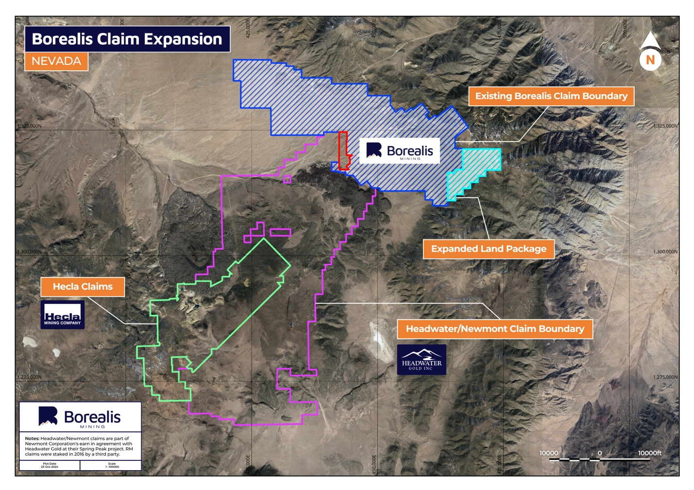
Figure 2: Map showing historical grab sampling results on the newly expanded claim package. Note the legend showing g/t Au on the lower right, and the north-east trend of mineralization.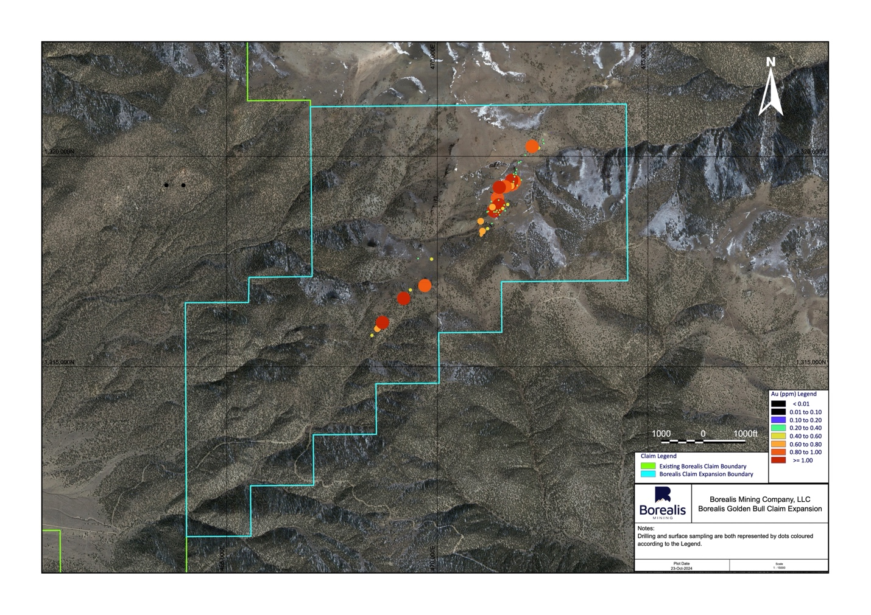

Qualified Person
The scientific and technical content of this news release was reviewed, verified, and approved by Kelly Malcolm, P.Geo., Chief Executive Officer of the Company, and a Qualified Person as defined by Canadian Securities Administrators’ National Instrument 43-101 - Standards of Disclosure for Mineral Projects.
Borealis Mine
The Borealis mine property, located close to the town of Hawthorne, NV, is fully permitted and equipped for present mine operations and future expansion, with existing open pits, heap leach pads, modern infrastructure, and a functional ADR facility which produces doré bars. The project has historically produced over 600,000 ounces of gold from an open pit heap leach operation. It is an under-explored property and has not been drilled since 2011. The property possesses high grade expansion potential with excellent historical drilling results, along with a number of untested regional targets.
About Borealis
Borealis is a gold mining and exploration company focused on exploration and resumption of production of the Borealis Mine in Nevada. The Borealis Mine is a fully permitted minesite, equipped with active heap leach pads, an ADR facility, and all necessary infrastructure to support a heap leach gold mining operation. In addition to the mine, the property, comprised of 751 unpatented mining claims of approximately 20 acres each totalling approximately 15,020 acres and one unpatented mill site claim of about five acres located in western Nevada, is highly prospective for additional high-sulfidation gold mineralization. Borealis is led by a strong board and management team, many of whom have founded, managed, and sold highly successful mining and exploration companies.
Upcoming Investor Conferences and Events
October 29-31: IMARC 2024, Sydney
November 11-12: Precious Metals Summit, Zurich
December 3-5: Mines and Money, London
For further information, please contact:
Kelly Malcolm
President and Chief Executive Officer
Email: info@BorealisMining.com
Office Tel: (289) 371-3371

This news release may contain certain “forward-looking information” within the meaning of applicable securities law. Forward looking information is frequently characterized by words such as “plan”, “expect”, “project”, “intend”, “believe”, “anticipate”, “estimate”, “may”, “will”, “would”, “potential”, “proposed” and other similar words, or statements that certain events or conditions “may” or “will” occur. These statements are only predictions. Forward-looking information is based on the opinions and estimates of management at the date the information is provided, and is subject to a variety of risks and uncertainties and other factors that could cause actual events or results to differ materially from those projected in the forward-looking information. For a description of the risks and uncertainties facing the Company and its business and affairs, readers should refer to the Company’s Management’s Discussion and Analysis. The Company undertakes no obligation to update forward-looking information if circumstances or management’s estimates or opinions should change, unless required by law. The reader is cautioned not to place undue reliance on forward-looking information.
Neither TSX Venture Exchange nor its Regulation Services Provider (as that term is defined in policies of the TSX Venture Exchange) accepts responsibility for the adequacy or accuracy of this release.

